国际教育资源共享峰会
—暨2016环球青少年大使计划秋季交流大会
邀请函
尊敬的先生/女士:
我们谨代表国际教育资源共享峰会暨2016环球青少年大使计划秋季交流大会组委会诚挚地邀请您出席于2016年10月17-18日在中国成都市举行的国际教育盛会。
本届盛会将有来自中国、美国、英国、加拿大、澳大利亚、新西兰、日本、韩国的政界、教育界官员和教育家代表、师生及家长代表以演讲、课堂比较展示、论坛等形式讨论国际教育资源共享、创造性学习、创造性教育的主题。

本次盛会仅限受邀教育界人士出席,请填写相关申请表以获得正式邀请。如对出席会议的各国学校有缔结姊妹学校的意愿,请填写贵校相关信息和与目标学校预约面谈的时间,以便届时面谈。

请参阅附件相关文件。如有任何问题,请与大会各组委会联系。
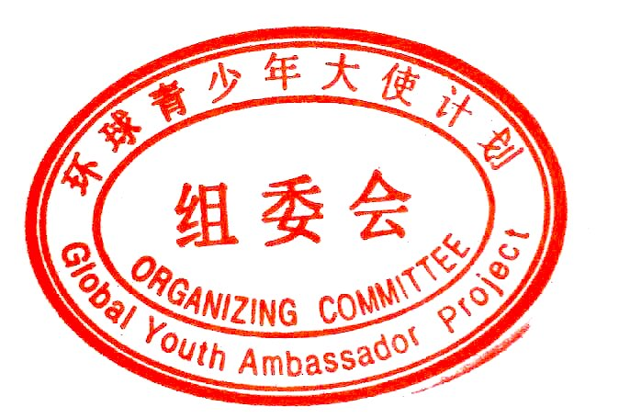
成都组委会:王思捷女士 联系电话:＋86 15810721916
山东组委会：李慎波先生 联系电话：＋86 15805331533
云南组委会：卜迪女士 联系电话：＋86 15887127790
河南组委会：王欢先生 联系电话：＋86 15503716076
2016年6月

Transnational Education Summit
—2016 Global Youth Ambassador Project Autumn Conference
LETTER OF INVITATION
Dear Sir or Madam,
On behalf of Transnational Education Summit/2016 Global Youth Ambassador Project Autumn Conference Organising Committee, I cordially invite you to attend this exciting event, with about 600 attendees, to be held in China Chengdu, Kunming, Zibo and Zhengzhou from Oct 15-24, 2016.
The meetings will include keynote speeches from Chinese and US top education and political leaders, educators from US, China, UK, Australia,Canada, New Zealand,Japan and Korea, Classroom Comparison Demonstrations, Seminars on Shared Classroom, Shared Curriculum, Creative Learning and Teaching by principals, teachers, students, parents and the education service industry.
After each city conference, some sightseeing tours will be arranged including visits to the Great Wall, Forbidden city of Beijing, Panda Breeding Base of Chengdu, the hometown of Confucius in Shandong, Highland Lake of Kunming or even the Skyscrapers in Shanghai!
The conference is an invitation-only event for educators and students. Many Chinese schools principals are looking for sister-school partnership. Please tick on the attached application form your time available and we will set up face to face meetings between schools for establishing partnership if you are also interested in sister school connections.
Please also find the attached event information and application form for your reference. If you have any further questions, please do not hesitate to contact us.
AIA US:  Mr. Kris Zhang Tel: +1 5038059927 | AIA UK:  Mr.Tom Saunders Tel:＋44 7854309235
AIA Australia:  Ms. Angela Cheung Tel: ＋61 410613008 | AIA New Zealand:  Mr. Mark Ma Tel: +64 9 3576666
AIA China:
Ms. Yuan Ma Tel: ＋86 4008180200

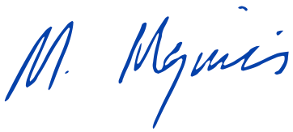
Sincerely Yours,

Mary MEZINIS, CEO
ADVANCED INTERNATIONAL ACADEMY
JUNE. 2016

